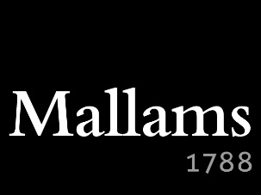
Charity Auction 2017
In October and November 2017, with the support of local auctioneers Mallams, 2017 High Sheriff Jane Cranston is running an online auction where she hopes to raise a significant sum for the High Sheriff’s Charitable Fund, with proceeds to Youth Challenge Oxfordshire, Aspire and SAFE!. To donate an auction lot, please complete this form.

DONOR
AUCTION LOT | (Description of prize, including restrictions and valid until date)
APPROXIMATE VALUE | (Or reserve price if appropriate) £
Would you like publicity? | Yes ☐ No ☐ | If yes, can you provide us with a logo in pdf format? | Yes ☐ No ☐
Are you able to provide photo(s) if appropriate? | Yes ☐ No ☐  Please attach original, high-resolution photos to your email
Who should we contact regarding information about the prize? | Name
 | Telephone number
 | Email

Please return this form to:

The High Sheriff’s Charity Auction, Peregrine, Besselsleigh, Oxfordshire OX13 5UP

or email to oxfordshirehighsheriff@outlook.com

